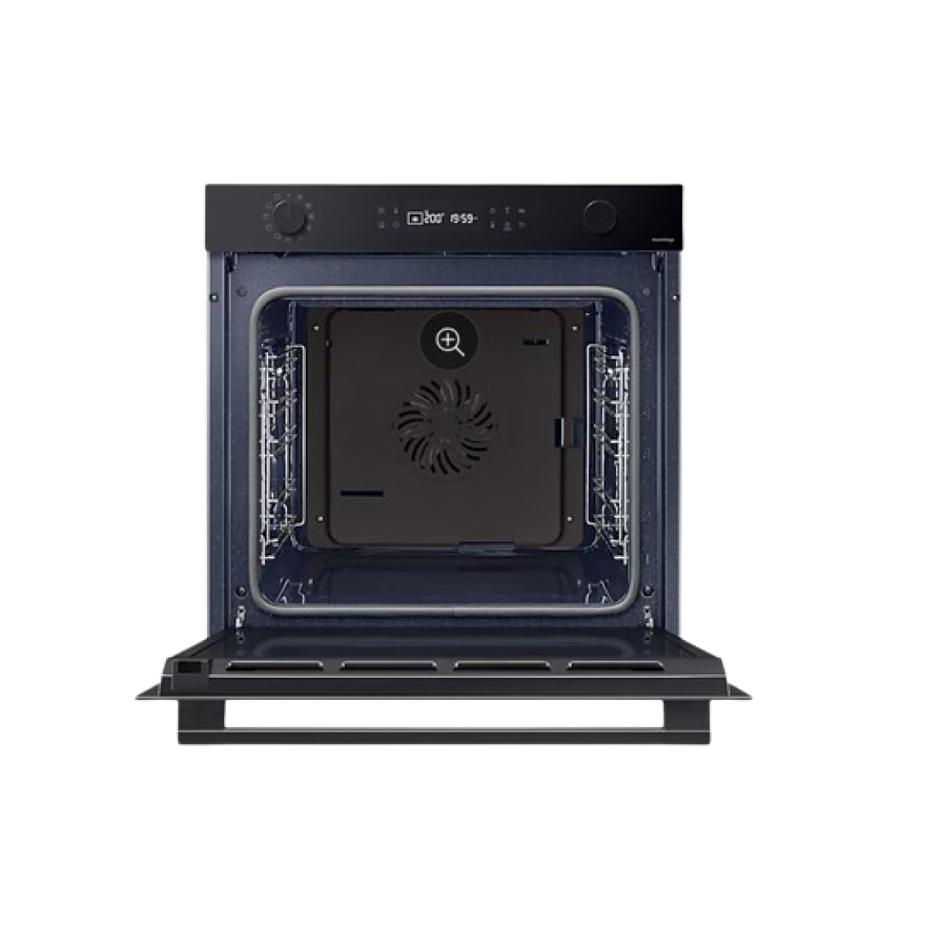 **Highlights**

**Natural Steam**

Enjoy deliciously juicy, but crispy food without the need for any specialist equipment.

**BESPOKE Color**

Give your kitchen a beautifully stylish and unique look that reflects your personal taste and complements your existing interior design.

**SmartThings Cooking**

Make your kitchen experience more joyful. SmartThings Cooking saves time and minimizes the burden of cooking.

**More joy, less burden**

**SmartThings Cooking**

Make your kitchen experience more joyful. SmartThings Cooking* saves time and minimizes the burden of cooking. By understanding your needs it recommends personalized recipes** and creates a weekly meal plan. It also offers a guided cooking experience and enables effortless grocery shopping***.

* Requires a wireless network, a Samsung account and the Samsung SmartThings App. The Samsung SmartThings App supports Android OS 8.0 (Oreo) or later, which is optimized for Samsung smartphones. This App also supports iOS 13 or later for iPhone models. The SmartThings App is available in the App Store and Play Store.  
** Available in certain languages, including English, French, German, Italian and Spanish.  
*** Only available in the UK and Germany. Other countries will be added soon.

**Always keeps the oven neat with heat**

**Pyrolytic Cleaning\***

Keep the inside of your oven neat and clean without wasting time and effort scrubbing or using costly cleaning products. A Pyrolytic Cleaning* system heats the cavity to burn off any grease and residue left from cooking. Everywhere is left spotless with only a few ashes to wipe away.

* Only available on certain models.

**Easy self-cleaning**

**Catalytic Cleaning\***

Save yourself the time and effort of scrubbing the oven. A Catalytic Cleaning* system makes it easy to keep the oven clean. The catalytic liner at the rear of the cavity absorbs grease from splashes and drips during cooking. So it cleans itself without any hard work or costly cleaning products.

* Only available on certain models.

**Cook food properly to suit your taste**

**Food Probe\***

Check the internal temperature of dishes more easily and ensure they are cooked to suit your taste. The Food Probe* eliminates any guesswork by clearly indicating when even large pieces of food have been cooked properly. And there is no need to waste time and heat opening the oven to check.

* Only available on certain models.

**Closes smoothly, gently and silently**

**Soft Close Door\***

Enjoy a more peaceful cooking experience with the Soft Close Door. It closes safely, gently and silently. The hinge makes the door move smoothly in the final few centimeters, so it slowly and quietly shuts, with no vibration or banging sounds.

*Specifications may vary by model.

**Cook much more**

**Big Capacity (76L)**

Create more and larger dishes with a massive 76 liter capacity oven. It opens up more possibilities in home cooking. You can prepare lots of different food together, like everything you need for a party. Or it can easily accommodate large items, like a king-size turkey, for a family gathering.

**A+ energy efficiency without compromise**

**Energy Efficiency – A+**

Make your home more energy efficient. You can use the whole oven and enjoy exceptional A+ rated energy efficiency with the Eco convention mode. It saves energy by using less power, but you still have the convenience of a very large and flexible oven space. And it reduces harmful CO2 emissions.

**Smooth gliding shelf**

**Telescopic Rail\***

Get things in and out of the oven much more easily. The Telescopic Rail slides in and out smoothly with hardly any effort, even if you’re using large or heavy pans. It creates much less friction, so it’s much easier to load and unload. And you can baste, turn and season food without any spills.

*Specifications may vary by model.

**How to measure**

**Specifications**

* Outside (WxHxD)**595 x 596 x 570 mm**

* Weight (Net)**32.0 kg**

* Energy Efficiency**A+**

* Convection**1800 W**